Supplementary Material

Supplementary Figures
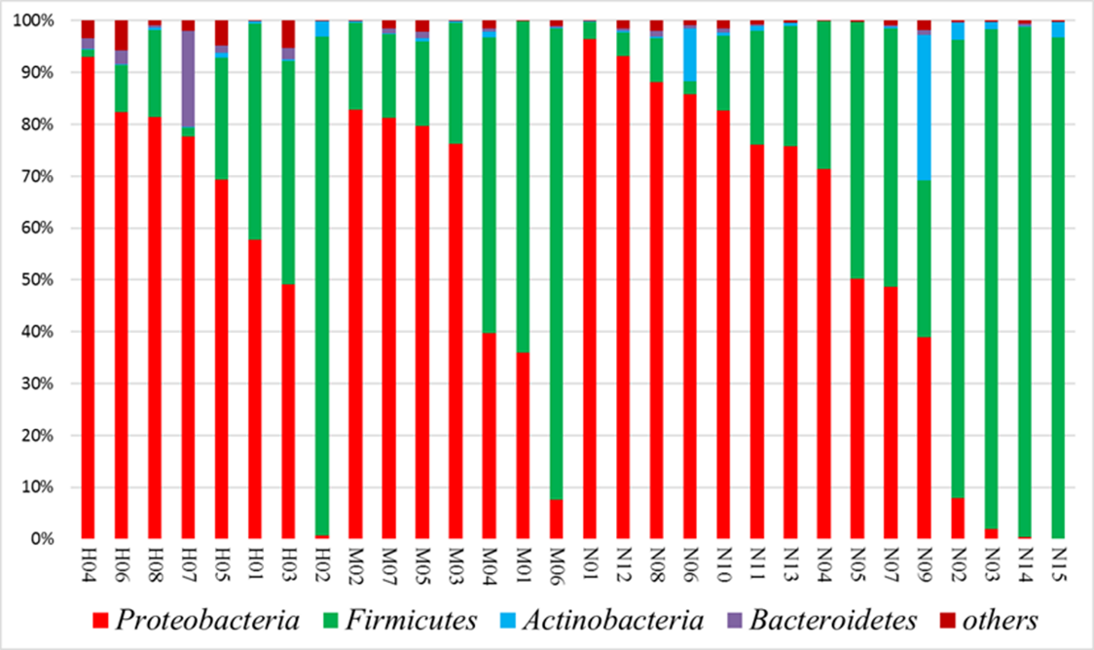
Supplementary Figure 1. Microbial communities in infants with ileostomy. The figure shows the relative abundance of the four dominant taxonomic phyla in patients with HD (H01-H08), MP (M01-M07), and NEC (N01-N15). HD: Hirschsprung's disease; MP: meconium peritonitis; NEC: necrotizing enterocolitis.

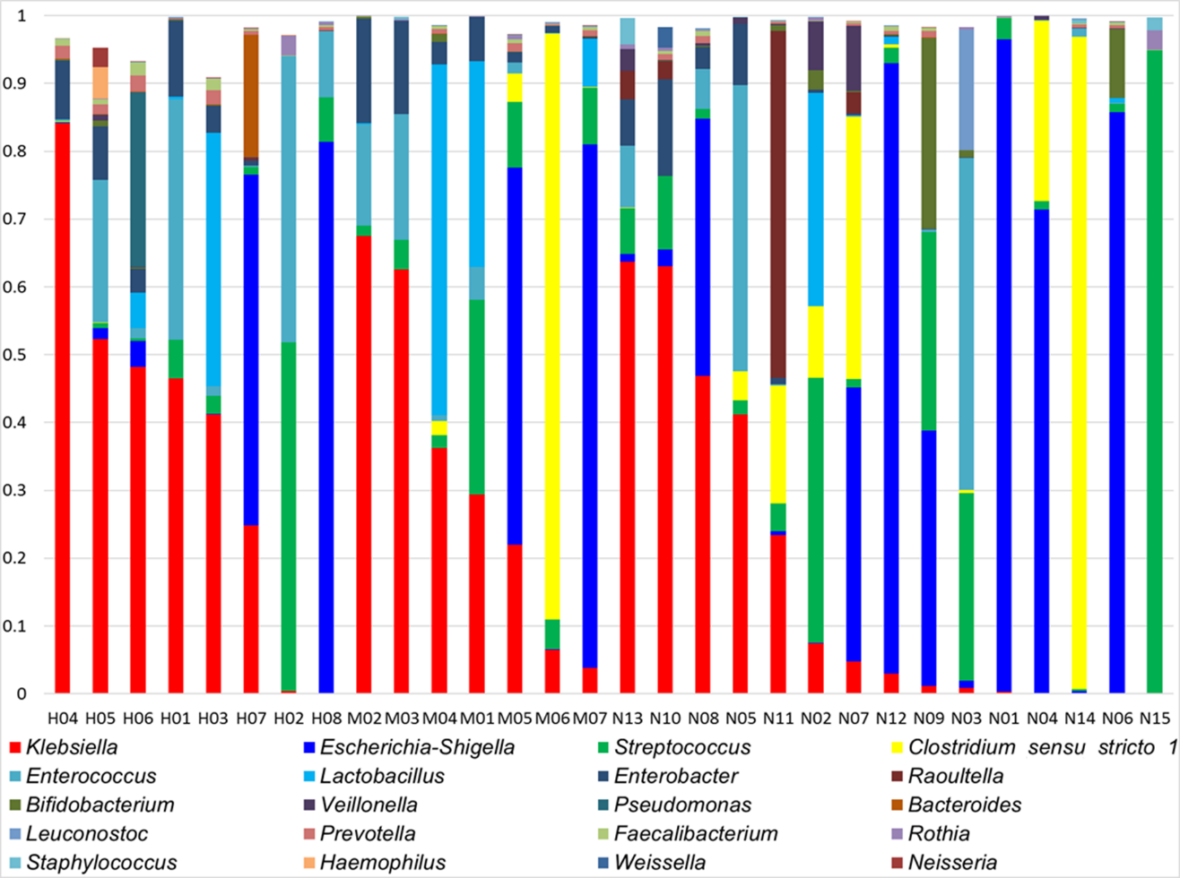
Supplementary Figure 2. Microbial communities in infants with ileostomy. The figure shows the relative abundance of the 20 taxonomic genera in patients with HD (H01-H08), MP (M01-M07), and NEC (N01-N15). HD: Hirschsprung's disease; MP: meconium peritonitis; NEC: necrotizing enterocolitis.

